E Buckmaster County Councillor Annual Report 2025 to 2026

County Elections May 2025
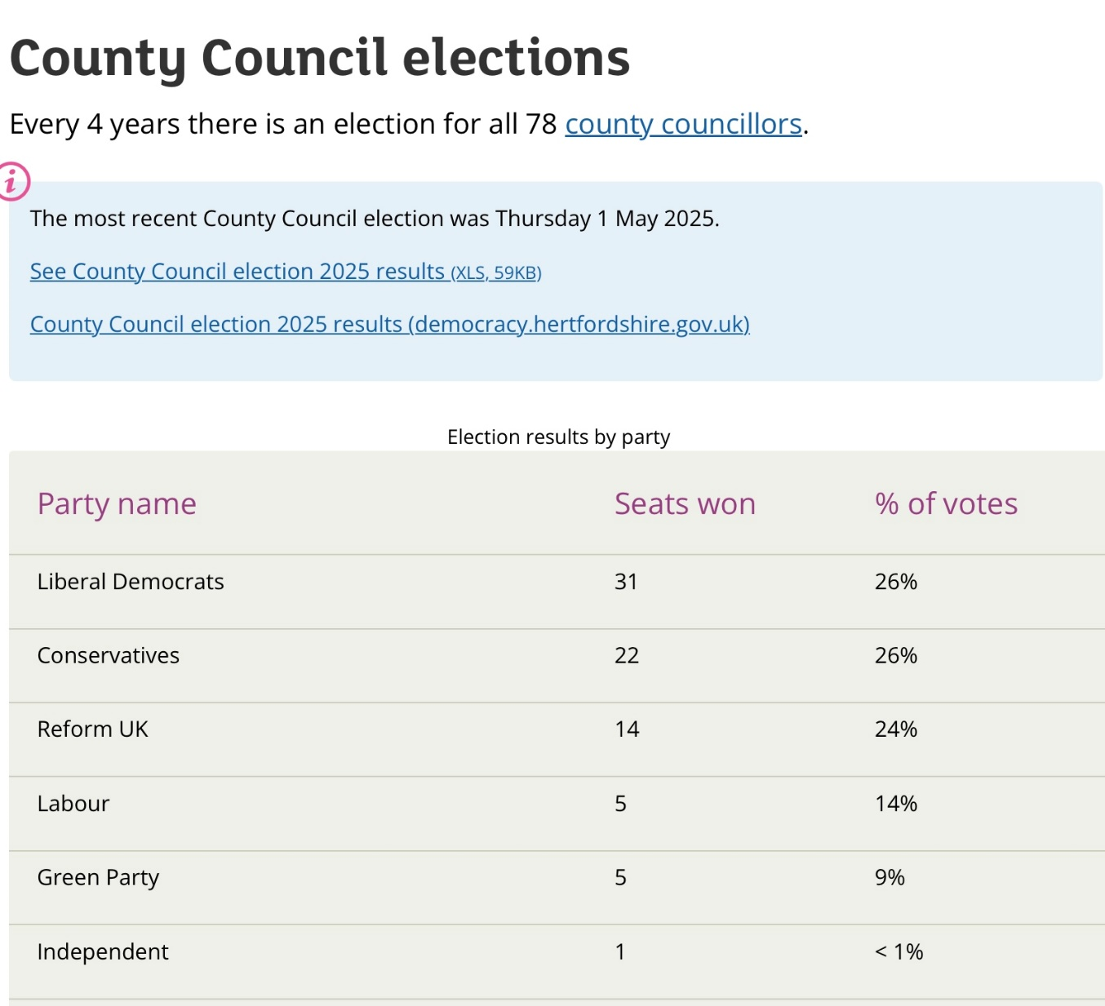

Eric Buckmaster Locality Grants awarded May 2025 to March 2026
 |  | Budget
 | Carried Forward | £674.00
 | budget 2024 to 2025 | £5,000.00
 |  | £5,674.00
Applicant organisation | Purpose | amount agreed
Bishops Stortford and Sawbridgeworth Breathe Easy Group | This group is for anyone who is living with a lung condition and would like to meet and support each other | £250.00
outreach work at High Wych school and village Hall | Preparitory work for community scarecrow festival | £150.00
Hertfordshire Constabulary | Antisocial behaviour signage | £297.00
Friends of Pishiobury Park | Bat Boxes | £210.00
Health and Independent Living Services | personalised nutrition support for older people | £250.00
Citizens Advice | volunteer recruitment and training in my locality | £300.00
Eastwick and Gilston Parish Council | towards village sign process | £168.00
Homestart East Herts | supporting local families Build stronger more sustainable family units | £300.00
Essex & Herts Air Ambulance Trust | air ambulance rescue | £200.00
Friends of Hailey Day Centre | TV for presentations and information and occasional entertainment. | £750.00
Wareside Parish Council | towards replacing benches in the village | £300.00
Sustainable Sawbridgeworth | towards promotional materials | £250.00
Fawbert & Barnard School | towards raised beds for growing vegetables and flowers | £200.00
Widford Playing Field Committee | towards replacement bench | £375.00
Community Alliance Broxbourne and East Herts | towards community transport for elderly and vulnerable residents | £200.00
Sawbridgeworth Cricket Club | towards equipment | £200.00
Graham School of Dance | towards Dance Competition costs for students | £250.00
 | Running Total | £4,650.00
 | amount remaining to carry forward to 2026/27 | £1,024.00

Highways Locality Budget. Councillors also have a Highways Locality Budget to be spent on highway maintenance in the areas they represent.
Allocations for year 25/26
Name / location | Activity | Reason | Cost | Target date
Cambridge Road, Sawbridgeworth - Footway Resurfacing | Footway Resurfacing | Priority agreed with the Local Community | £9000 | 31/03/2026
Cambridge Road, Sawbridgeworth - New SID Sign in New Socket | Traffic Signs | Priority agreed with the Local Community | £5100 | 31/03/2026
Footpath 29, Sawbridgeworth - Footway Resurfacing | Footway Resurfacing | Priority agreed with the Local Community | £9450 | 31/03/2026
High Wych Lane, High Wych - Carriageway Resurfacing | Carriageway Microsurfacing | Priority agreed with the Local Community | £21750 | 31/03/2026
High Wych Road, Sawbridgeworth - New SID Sign in a new Socket | Traffic Signs | Priority agreed with the Local Community | £5100 | 31/03/2026
Hoestock Road, Sawbridgeworth - PTRO (Waiting Restrictions) | Permanent Traffic Regulation Order | Priority agreed with the Local Community | £3200 | 31/03/2026
Hunsdon Pound, Stanstead Abbotts - New "No through route" & "Unsuitable for HGV" signage | Traffic Signs | Priority agreed with local Councillors | £1100 | 31/03/2026
Lawrence Avenue Area, Stanstead Abbotts - PTRO Waiting Restrictions (Design and Public Engagement) | Permanent Traffic Regulation Order | Priority agreed with the Local Community | £3500 | 31/03/2026
London Road, Sawbridgeworth - Waiting Restrictions (Design and Public Engagement) | Permanent Traffic Regulation Order | Priority agreed with the Local Community | £1850 | 31/03/2026
Sawbridgeworth NE Quadrant - 20 MPH Zone After Study | Transport/Traffic study | Other | £875 | 31/03/2026
Standard TTRO Contribution | Prep work TTROs - Traffic Management | Other | £500 | Scheme complete
Station Road, Sawbridgeworth - New Pedestrian Guardrail | Pedestrian Improvement | Priority agreed with the Local Community | £5425 | 31/03/2026
Station Road, Sawbridgeworth - Sign replacement (Parking signs) | Traffic Signs | Priority agreed with the Local Community | £750 | 31/03/2026
Various Roads, Sawbridgeworth Town Centre Area - PTRO (Waiting Restrictions) | Permanent Traffic Regulation Order | Priority agreed with local Councillors | £4200 | 31/03/2026
Ware Road, Widford - S bend warning signage enhancement | Traffic Signs | Priority agreed with local Councillors | £4800 | 31/03/2026
West Road, Sawbridgeworth - Carriageway Resurfacing | Carriageway Microsurfacing | Priority agreed with the Local Community | £12400 | 31/03/2026

Total allocated for year: £89000

Please note some of the above still need to be implemented and there may be some things that were done this financial year but were budgeted for in the previous year.

HCC Minerals and Waste Local Plan
It had been expected during this Civic year that there would be progress in the Minerals and Waste Local Plan. The County Council needs to have a 7 year supply of minerals. However a planning application for a site at Ellenbrook (Hatfield Airdrome) was refused at committee. It was considered by the Planning Inspector and Secretary of State who then said there should be a further public hearing. This delay has meant there is no prospect of progressing the plan until there is certainty over the Hatfield site. However we must be aware that this does not preclude the applicant for Briggens, Tarmac, from submitting a speculative application.

County Hall marketed for sale with funds to be reinvested in vital services

Hertfordshire County Council has confirmed plans to market the entire County Hall site in Hertford for alternative uses following a meeting of the Resources and Performance Cabinet Panel, subject to final Cabinet approval on Monday 23 June.
Work was undertaken to create new spaces to allow for democratic meetings to take place at the council’s Stevenage campus, including a Full Council Chamber and Committee rooms.

Lifesaving equipment to be available at every Hertfordshire Fire Station
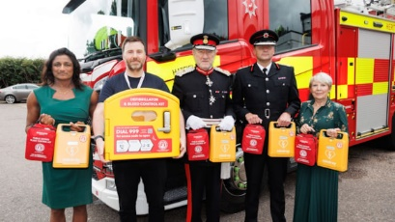
Hertfordshire County Council and local charity Hearts for Herts have teamed up to ensure that publicly accessible lifesaving equipment is available at every fire station in the county.
Fourteen units containing a defibrillator and bleed kit have been donated, co-funded by Hertfordshire County Council Public Health and volunteer-run Hearts for Herts Charity. This equipment is crucial in emergencies, significantly improving survival rates from out of hospital cardiac arrests and managing severe bleeding until emergency services arrive. Hertfordshire County Council and Hearts for Herts will continue to collaborate on future installations.

Adult social care requests to Herts County Council increase by 20% in 2024 to 25
Hertfordshire County Council received over 33,000 requests for adult social care assistance in the last financial year “New requests for support rose to 33,641, marking a 2% increase from 2023-24 and a significant 20% rise from pre-Covid levels.”

Government’s Fair Funding Review plans estimated to cost Hertfordshire County Council £50 million a year
Hertfordshire County Council has formally responded to the Government’s Fair Funding Review 2.0 consultation and called on Ministers to rethink proposals which could remove around £50m from the budget and lead to consequential adverse impact on services. However these reductions needed to be reflected in the 2026 to 27 budget.

Local Government Reorganisation In February 2025, the Government invited councils to submit proposals for local government reorganisation to simplify local government and reduce costs. The Government in February launched a seven-week statutory consultation on the proposals.
In Hertfordshire, there are currently two types of council delivering services (although parish and town councils also operate in some areas):
- District/borough councils provide services such as social housing and homelessness support, leisure services, town planning, street cleansing, waste and recycling collections, community and cultural centres, and council tax and business rates collection.
- The county council is responsible for services including children’s social care, education (including special educational needs), libraries, highways, recycling centres, public health and trading standards
Under the Government’s plan, these councils will be replaced by new unitary councils that will deliver all services currently provided by the county council and the district/borough councils.
Following a series of engagement events for residents and stakeholders, plus an online survey, Hertfordshire's 11 councils, together with the Police and Crime Commissioner, submitted proposals for two, three and four unitary council models for the Government to consider.
Full details of the three proposals, including business cases, financial analysis, maps showing the proposed boundaries, and a link to the Government’s consultation are available at: www.hertfordshire-lgr.co.uk

Secondary School Admissions
Allocations for secondary and upper schools for September 2026, were released, Monday 2nd March.
94 per cent of children have been allocated a place at one of their preferred secondary or upper schools by Hertfordshire County Council. Applications are slightly down compared to last year with 14,519 applications for Hertfordshire children. 78 per cent gained a place at their first preference school.
In the tables below you can see the results for each parish in East Hertfordshire for the allocations against each preference ranked 1 to 4
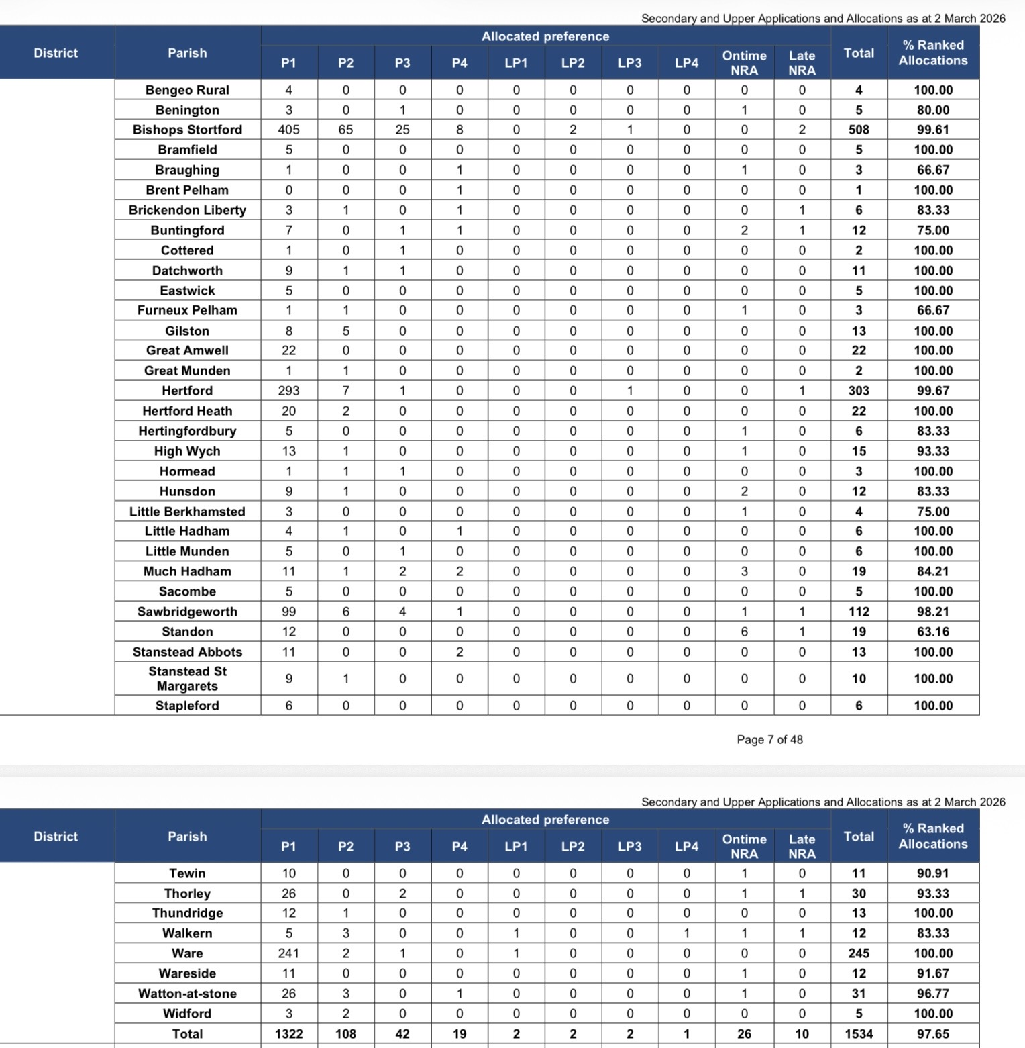

Free bus travel scheme announced for care experienced young people
Hertfordshire County Council has announced it will fund free bus travel for young adults, 18-25, who have previously been in its care.
Around 1,000 young people are expected to benefit from the scheme, which will launch in early March and be trialled for 12 months. The scheme will utilise the existing Intalink App to provide a 100% discount on Intalink Connect Tickets, which allows unlimited travel on all buses in Hertfordshire (and some points beyond).
This news comes as councillors agreed to extend an existing council tax support scheme for care leavers, which will raise the age that care leavers will get council tax reimbursed to them from 21 to 25, at a meeting of Full Council on Tuesday 17 February. This and the launch of the council’s new corporate parenting strategy highlights a commitment to those children and young people currently in our care and how the council plans to continue to help them as they enter adulthood.

East Herts Council Implement the previous Conservative Government Simpler Recycling waste collections
This also included a new services contract with Veolia for collections and street cleansing. The Waste Disposal Authority is the County Council.
The updated service included weekly food waste and separate containers for card and paper, plastics and foil, a smaller general waste container and garden waste. All three weekly except the paid for Garden waste which is fortnightly. My observation is that the system is at last working well and there is an app to remind residents what to put out on each occasion. However the initial deployment was chaotic with wrong containers and information being sent to flats, containers not delivered, and several weeks of missed collections owing to lack of, or failure to provide, data between the council and contractor. For a period of time the customers services were receiving more than 1,000 calls a day and many hung up because they could get through. However with the new system and especially with food waste collection I would expect East Herts recycling rates to rise from a previous 49 percent to within some of the best performances across County.

Planning
East Herts has failed to achieve a five-year housing supply owing to delays of many major schemes and is unlikely to achieve the target. Unfortunately, this has meant several speculative housing applications, which were not in the Local Plan, being approved on ‘tilted balance’. The District Plan Executive Panel is due to convene shortly to consider the process for the review of the District Plan which will include higher Government targets. A ‘call for sites’ was undertaken with many land owners submitting. These will be assessed and filtered and reviewed along with other technical information contributing to the review.
Lane.

Local Flood Risk Measures Update
Good to see the progress made in various areas towards prevention of flooding
- Cappell Lane, Stanstead Abbotts Construction of the leaky dams is completed.
- We are assessing the success of the dams via the monitoring installed at the culvert and will be completing inspections throughout the year.
Roydon Road and Stanstead Abbotts Drain
The Natural Flood Management project in the upper reaches of Stanstead Abbotts Drain has recently been completed, installing 10 leaky dams of varying types.
The aim is to reduce the amount of debris that travels downstream towards the trash screen on Roydon Road, and can hold back some peak volumes of flood water during heavy rainfall events.
Over the next two years the Environment Agency will be monitoring the performance of the project in a number of ways:
- Monitoring the flows / levels using our temporary telemetry site installed a short distance upstream of the trash screen
- Visiting the structures every few months or after heavy rainfall events to observe and document their condition and performance
- Reviewing the trash screen and CCTV feed to understand if the amount or frequency of debris collecting there has changed
- Contractors will also be undertaking routine maintenance of the project twice per year
Hunsdon Alleviation Scheme Clearance works were carried out on the watercourse in December.. We are currently waiting on an update from our Highways team on these works.
Other areas having flood investigations include Bullfields, Hoestock Road, and High Wych Lane

Councillor Eric Buckmaster Report of 2025 to 2026 for Annual Meetings of Town and Parishes to be held April/May 2026

